**M-TECH INDUSTRIAL ENGINEERING**

**TECH**

**M**

**FABRICATORS, ERECTORS AND SUPPLIERS OF INDUSTRIAL PLANTS**

TO WHOM IT MAY CONCERN

This is to certify that <Name> S/o <fname> NIC Number <CNIC> has worked with our organization as <Designation> from <From> to <To> at following project.

* 1. ***Lucky Cement Line “C” “D” Project Pezu***
  2. ***Khan (N.W.F.P)***

He has good knowledge at all Fabrication activities. During the period of collaboration we found him honest, hardworking and devoted to him duties.

We wish him every success in future.

***For M-TECH Industrial Engineering***

lani

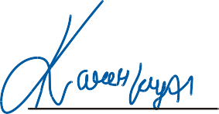

Mushtaq Jil

**HEAD OFFICE** : P-113/2 - Madina Town - Saeed Colony - Faisalabad.

Tel: +92 - 41 - 8531484 Fax: +92 - 961 - 780433 E-mail: m-tech_ph@hotmail.com

**WORKSHOP** : 10 KM Faisalabad Sheikhupura Road, 200 Adda, Faisalabad.

Tel: 0300-5799102 - 0300-7633459